Spatial machine learning
Prof. Katarzyna Kopczewska
University of Warsaw, Faculty of Economic Sciences
kkopczewska@wne.uw.edu.pl
updated 10.03.2026

Spatial Random Forest

Spis treści
# 1. Data overview 2
# Traditional Random Forest model – regression (continuous y) – with spatial variables 4
# model, variable importance and partial plot 4
# decision tree 8
# optimization of models – hyperparameter tuning 11
# Spatial Lag Model Tree 15
# Spatial Random Forest 19
#*** Random Forest in classification (for binary y) 24

Spatial modelling is about using the information from the neighbourhood and from location. Socio-economic phenomena (and many others) have two regularities:
- Spatial autocorrelation – data are similar in the closest neighbourhood - when we know one value, we can easier predict the neieghbourhood value
- Spatial heterogeneity - data build spatial groups / clusters that are different from each other (so data are similar locally and dissimilar globaly)
- Controlling for neighbourhood and location is for two purposes: to have better predictors (explanatory variables) and to eliminate spatial behaviour from residuals of the model (to make residuals random)
Spatial components in the models:
- Distance to major cities (im km or as a dummy for radial catchment area)
- Location in high-density (dummy or a variable expressing this density)
- Structure of the neighbourhoods (how many similar / dissimilar entities are around the observation)
- Mutual distances between observations (distance matrix) and their eigenvalues / PCA values
- Spatial neighbourhood (given with the spatial weights matrix)
They are included as explanatory variables or as a part of the algorithm.

# 1. Data overview

Let’s plot the point data for which we model relationships – these are locations of firms. One can see they are unevenly distributed across space – so there are places of low density and high density. Why? Urban agglomerations attract firms, peripheral places less interesting, there are no firms in the forest, lake, on highway and in the cornfield.

# plot of the location of points
plot(st_geometry(firms.sf), pch=".")
plot(st_geometry(region.pov), add=TRUE)
plot(st_geometry(region.voi), lwd=2, add=TRUE)

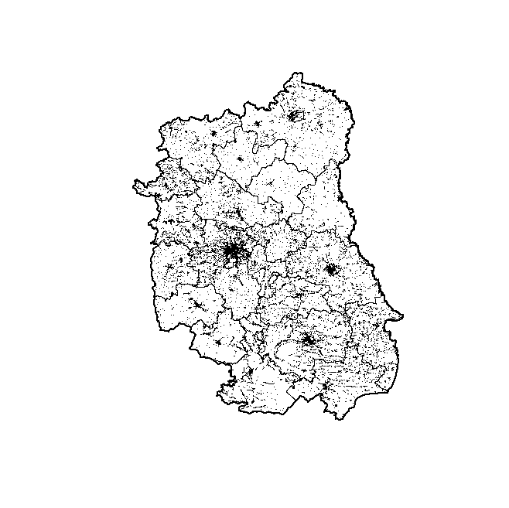

Firms data can be supplemented with regional data from official statistics – like unemployment rate, investment, GDP etc. A nice way to visualise them is by using interactive plotting, available with mapview::.

# regional subsets of data
region.data<-data[data$region_name=="lubelskie", ] # cut poviat data to region
region.data23<-region.data[region.data$year==2023,] # cut for a selected year
region.pov$dist<-region.data23$dist # transfer variable to map

# interactive maps
library(mapview) # interactive plotting
mapview(region.pov["dist"], col.regions=sf.colors(10)) + mapview(region.voi, zcol=NULL, alpha.regions=0.1)

mapview(firms.sf[firms.sf$SEC_PKD7=="G",], zcol="loc_share_selfsector")

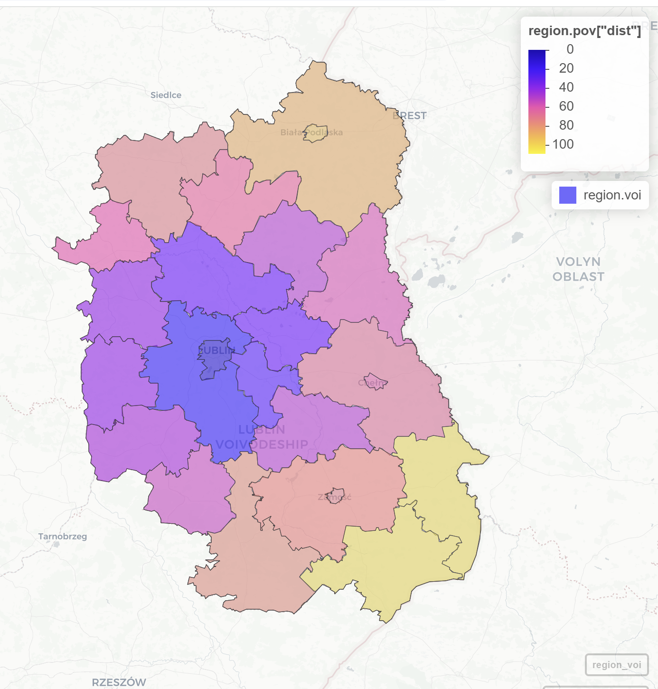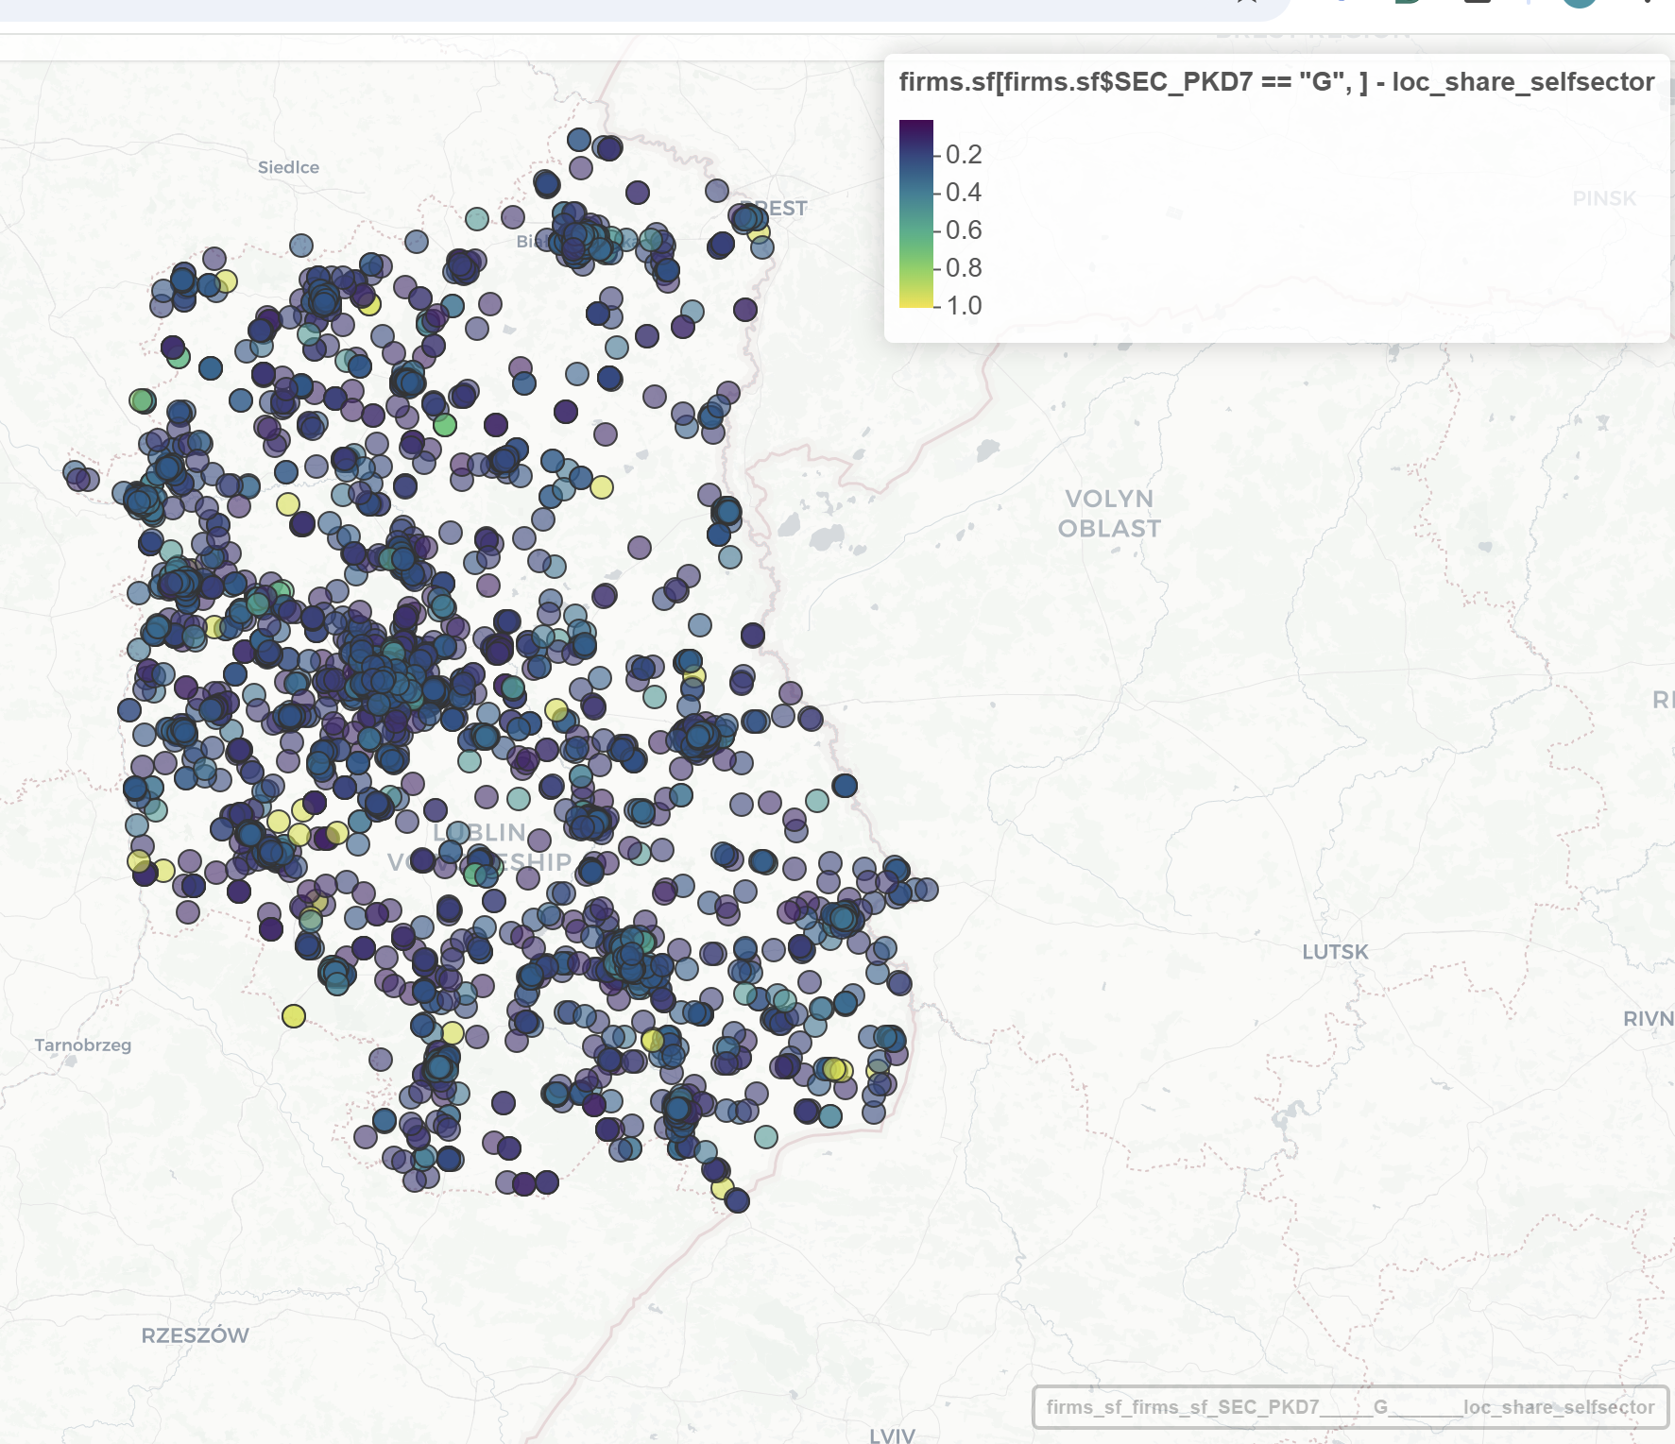

However, the most traditional and practical way is to make static plots – available with plot() or ggplot().

# static maps
plot(region.pov["dist"])

plot(firms.sf["dist.lublin"], key.pos=4, pch=16)

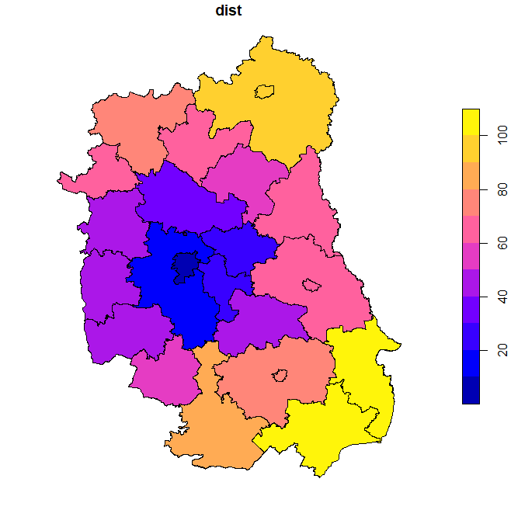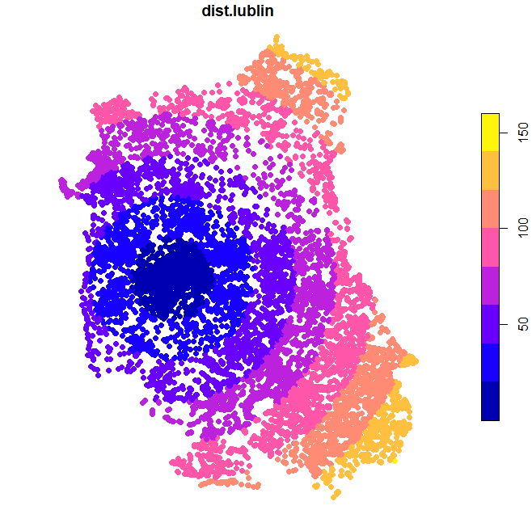

# static maps
ggplot() + geom_sf(data=region.pov, aes(fill=dist)) + labs(title="Distance to the core cities within the NUTS2 division")

ggplot()+ geom_sf(data=firms.sf, aes(col=subreg))

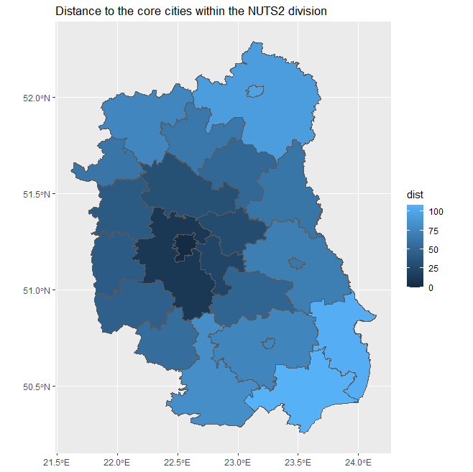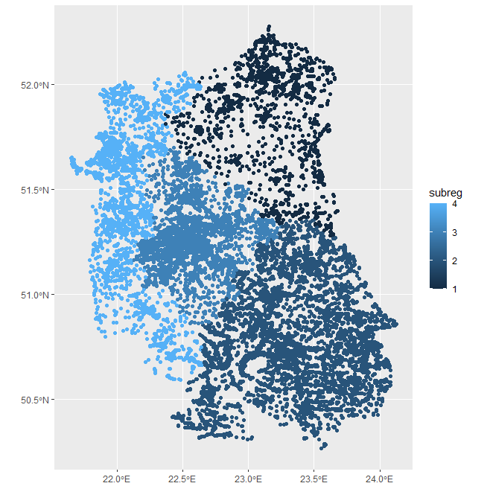

# Traditional Random Forest model – regression (continuous y) – with spatial variables

Random Forest is an ensemble machine learning method based on many decision trees. Instead of building one model, it builds hundreds of trees and combines their predictions. Main principles:
- Bootstrap sampling: Each tree is trained on a random sample of observations (with replacement). This increases model robustness.
- Random selection of predictors: At each split in the tree, only a random subset of predictors is considered. This prevents dominance of strong predictors and increases diversity of trees.
- Aggregation: For regression problems, final prediction is average prediction from all trees. This reduces overfitting and variance of predictions.
Random Forest can handle non-linear relationships, interactions between variables and complex spatial effects. For example, distance to city may have nonlinear effect (strong near the city, weak further away). Traditional linear regression may miss this.

One possibility in “spatial machine learning” is to include spatial variables into the model specification – as predictors (explanatory variables). The model below explains firm’s local agglomeration (logAggTOTAL) (how many firms are around given firm) with the sectoral dummies for the firm (dummy_agri, dummy_prod, dummy_constr – and skipped dummy_serv), its profitability (roa) (generated, not real!), local density of population (locPdens) (how many people lives around the firm), firms’ density given as dummy (COREfirms), number of big firms around (locBIG) and distances to major and regional cities (dist.lublin, min.dist).

Example below uses randomForest:: package. We operate on firms.sel object – this is only 1000 firms, selected from bigger dataset (for quicker calculations).

# model, variable importance and partial plot

library(randomForest)

eq<-locAggTOTAL ~ dummy_agri + dummy_prod + dummy_constr + locPdens + COREfirms + locBIG + dist.lublin + min.dist + roa

y<-firms.sel[, "locAggTOTAL"] # y variable – continuous
x<-firms.sel[,c("dummy_agri", "dummy_prod", "dummy_constr", "locPdens", "COREfirms", "locBIG", "dist.lublin", "min.dist", "roa")] # set of x variables - predictors

rf.global<-randomForest(x, y, importance=TRUE)
rf.global
Call:
randomForest(x = x, y = y, importance = TRUE)
Type of random forest: regression
Number of trees: 500
No. of variables tried at each split: 3
Mean of squared residuals: 1069.463
% Var explained: 96.72

The model explains 96.7% of variance, which is extremely high. Local agglomeration of firms is strongly explained by included variables – many of them are spatial. However, machine learning models often achieve very high fit because they capture nonlinear patterns.

varImpPlot(rf.global) # variable importance
partialPlot(rf.global, x, locPdens, xlim=c(0,120)) # partial plots

# %IncMSE – Increase in Mean Squared Error
# IncNodePurity - Increase in Node Purity
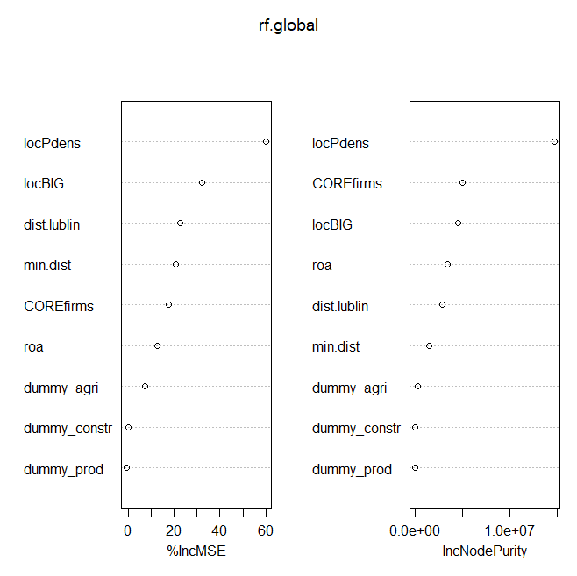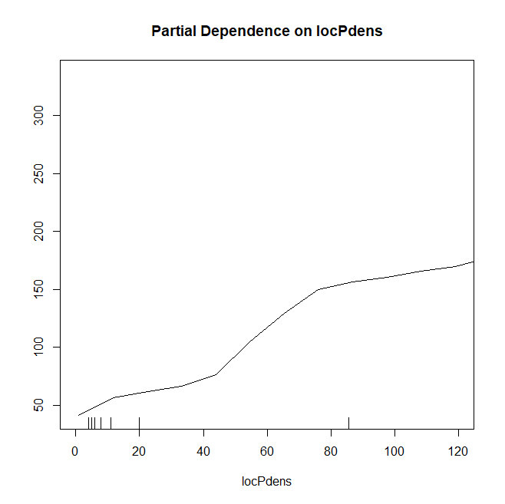

Variable importance plot shows two metrics: %IncMSE (Increase in Mean Squared Error) when the variable is randomly permuted. If permuting the variable strongly worsens prediction, the variable is important. For example: if shuffling locPdens causes large increase in prediction error, this means it is a very important variable. IncNodePurity measures how much the variable reduces variance inside tree nodes. The higher the value the more variable contributes to splits.
Most important variables: locPdens – local population density, COREfirms – location in firm core areas and locBIG – number of large firms nearby. These variables describe local economic environment. Firm agglomeration is mainly driven by local economic density. This matches agglomeration theory in economic geography.
Moderately important are dist.lublin and min.dist - these variables represent distance to major cities. Distance to urban centers still matters but less than local density effects. This is typical because local environment is more important than regional accessibility.
Least important are sectoral dummies: dummy_agri, dummy_prod and dummy_constr. Sector of the firm has much weaker influence on local agglomeration than spatial context.

The partial plot shows the effect of locPdens - how the predicted value of Y changes when one variable changes while others are averaged. So it approximates marginal effect in a non-linear model. The observed pattern is that when population density increases, predicted firm agglomeration also increases - the relationship is non-linear. Pattern visible in the plot: for low density (0–30) - small increase in agglomeration, for medium density (30–70) - rapid increase, for high density (>70) - effect stabilizes. Agglomeration economies become much stronger in moderately dense areas, but after some point additional density produces smaller marginal gains. This is consistent with urban economic theory.

* * *

The package randomForestExplainer:: helps to understand how variables are used across the trees of the forest. Standard RF outputs usually focus on predictive importance, such as %IncMSE or node purity. In contrast, randomForestExplainer also shows: how early a variable appears in the trees, how often it is used, how these different importance measures relate to each other. This is especially useful in spatial machine learning, where one may want to distinguish between variables that are globally predictive and variables that mainly help to refine local partitions.

Minimal depth - the depth of the first split using a given predictor. It measures how close to the root of the tree a variable first appears.
- Low minimal depth means the variable is used very early.
- High minimal depth means the variable enters only later in the tree.
- Variables that tend to appear near the root are usually more important for structuring the data.
So this measure captures something slightly different from permutation importance: it tells us whether a variable is important for the main architecture of the forest.

Here, locPdens has the smallest minimal depth and appears very early in most trees, what means that thi is
the main splitting variable in the forest and plays the key role in partitioning the data. So this measure captures something slightly different from permutation importance: it tells us whether a variable is important for the main architecture of the forest. Other variables, such as locBIG, COREfirms, roa, dist.lublin, min.dist also have relatively low to moderate minimal depth, meaning they often appear in upper or middle parts of the trees. This suggests that they are important secondary splitters: they do not define the first major partition as strongly as locPdens, but they help refine the structure of the forest. The sector dummies (dummy_agri, dummy_constr, dummy_prod) have clearly larger minimal depths and often appear later in trees. This means they are not important for the main structure of the prediction process. They may still be used in some local branches, but they are not central drivers of agglomeration.Plot of min_depth distribution - a variable is more important when its distribution is concentrated at small depths, its mean minimal depth is low, and/or it appears in many trees.

library(randomForestExplainer)

min_depth_frame<-min_depth_distribution(rf.global)
head(min_depth_frame, n=10) # the lower the min_depth the more important variab
tree variable minimal_depth
1 1 COREfirms 2
2 1 dist.lublin 0
3 1 dummy_agri 3
4 1 dummy_constr 4
5 1 dummy_prod 6
6 1 locBIG 3
7 1 locPdens 1
8 1 min.dist 1
9 1 roa 3
10 2 COREfirms 1

plot_min_depth_distribution(min_depth_frame)
plot_min_depth_distribution(min_depth_frame, mean_sample="relevant_trees", k=15)

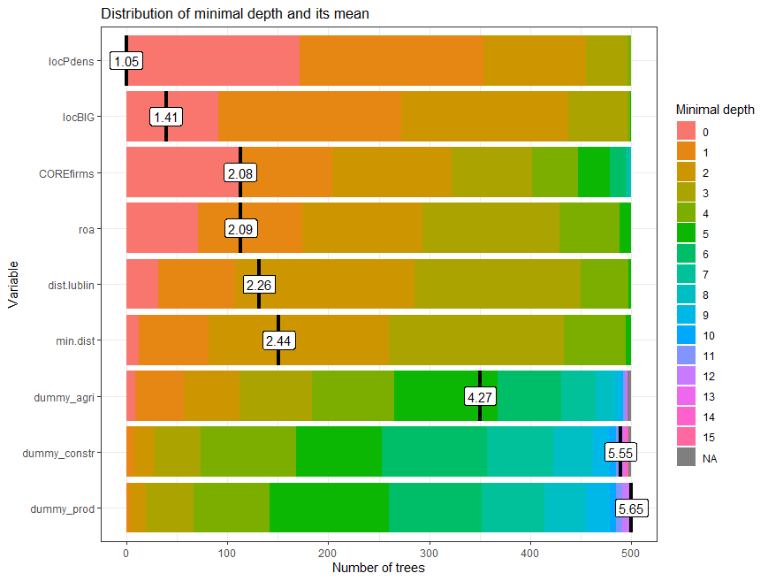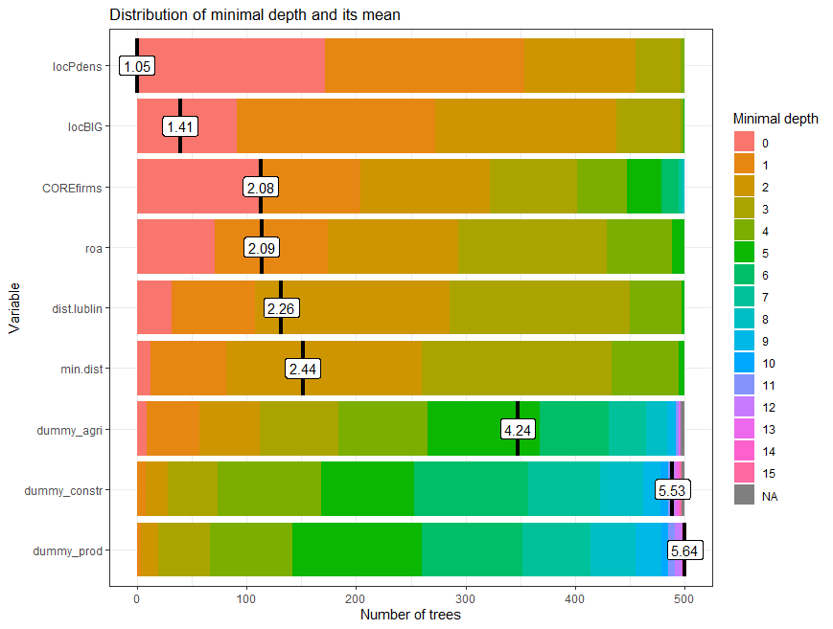

Importance measures compute everal metrics at once. Main intuition
- mean_min_depth: how early a variable is used
- no_of_nodes: how often a variable is used in splits
- times_a_root / number of root uses: how often the variable is the first split
- mse_increase: how much prediction worsens when the variable is permuted
- node_purity_increase: how much the variable reduces impurity
- p_value: significance of minimal depth relative to a null expectation
Together, these measures distinguish between variables that are: globally predictive, frequently used, structurally important, or only locally relevant.

Multi-way importance plots combine: position of the variable in the trees, how often it is used, and sometimes whether it belongs to the top group. In the example, locPdens clearly dominates: it has low mean minimal depth, high number of nodes, and strong overall presence. This means that locPdens is both an early splitter and a frequently used variable, so it is the central structural predictor in the forest.

MSE increase vs node purity increase - this plot compares the two classic RF importance measures. In the example, locPdens is far ahead of all other variables on both axes as it causes the largest increase in MSE when permuted and it contributes the most to node purity. So this is the strongest possible confirmation that locPdens is the key predictor.

importance_frame<-measure_importance(rf.global)
plot_multi_way_importance(importance_frame, size_measure="no_of_nodes")
plot_multi_way_importance(importance_frame, x_measure="mse_increase", y_measure = "node_purity_increase", size_measure="p_value", no_of_labels=5)

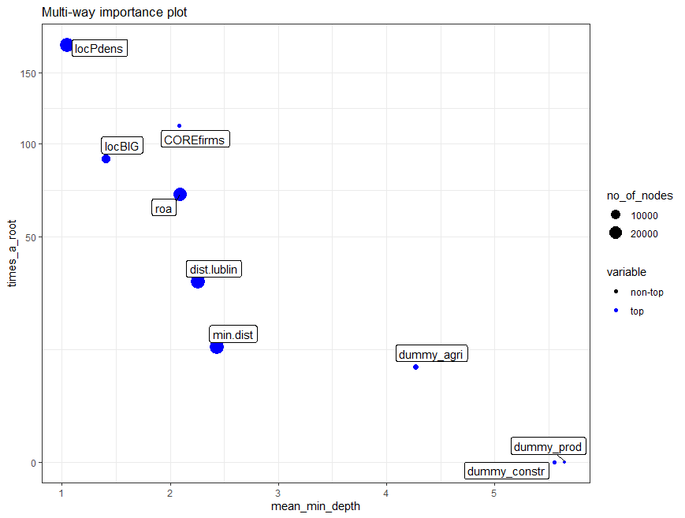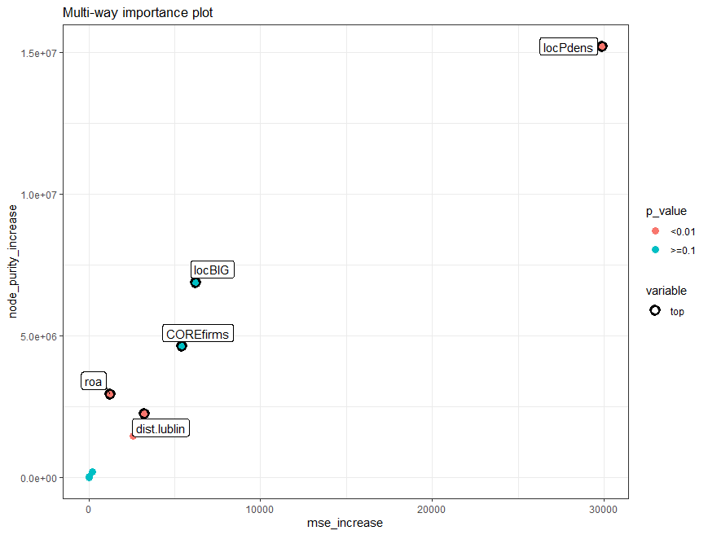

Plots of importance show pairwise relationships between different importance measures.It is important inspection, as different importance measures do not always rank variables in the same way. So this plot helps students understand that “importance” is multidimensional. In the example, several measures are positively correlated, especially among the major variables, e.g. variables with low mean minimal depth tend to have higher node counts, or variables with higher MSE increase often also have higher node purity increase. This means the forest gives a fairly consistent picture of importance. However, the correlations are not perfect, which is also instructive. It shows that different measures capture different aspects of variable use.

Plots of importance rankings compare the ranking of variables across different importance metrics. One can check if the same variable emerges as important regardless of how importance is defined - so the conclusion is not accidental or method-specific.

plot_importance_ggpairs(importance_frame)
plot_importance_rankings(importance_frame)

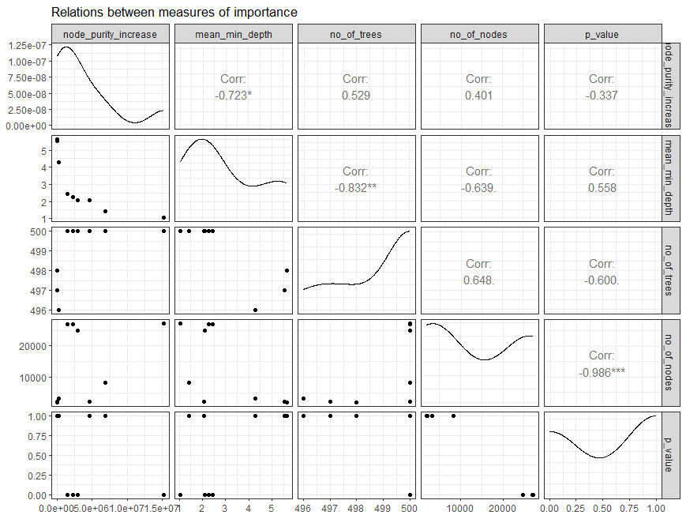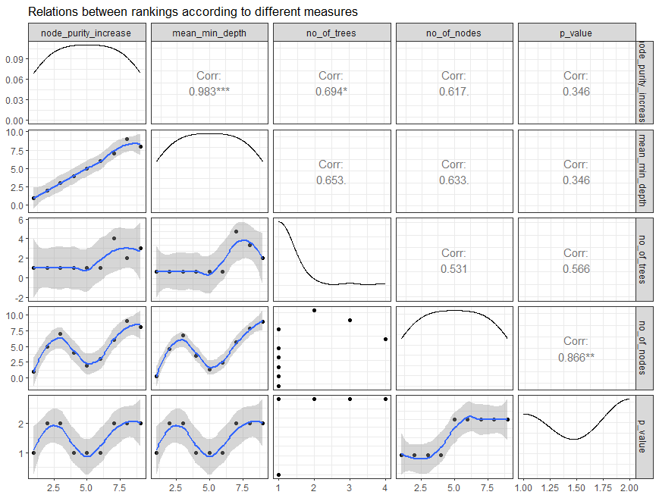

# decision tree

To better understand how Random Forest works, it is useful to visualise one regression tree. A tree recursively splits the observations into increasingly homogeneous groups, using thresholds in explanatory variables. Random Forest is made of many decision trees, so before interpreting the whole forest it is useful to inspect one single tree. This helps us understand the logic of recursive partitioning: the algorithm repeatedly splits the dataset into more homogeneous groups, using predictor values that best reduce variation in the dependent variable.
The code estimates a regression tree with rpart(), using the same formula as in the Random Forest model. The argument cp=0.001 allows the tree to grow relatively deep, so that more splits and relationships can be seen. The function prp() then draws the tree.
This plot is mainly for understanding the logic of tree-based models, showing which variables are used first to split the data, illustrating non-linear effects and interactions and explaining the intuition behind Random Forest. A single tree is usually not the final model we rely on, because it can be unstable and sensitive to the sample. But it is very useful for intuition, because it is interpretable.

# visualization of random tree
library(rpart)
library(rpart.plot)
library(PASWR)
cart<-rpart(eq, data=firms.sel, cp=0.001)
prp(cart, type=4, extra=1)
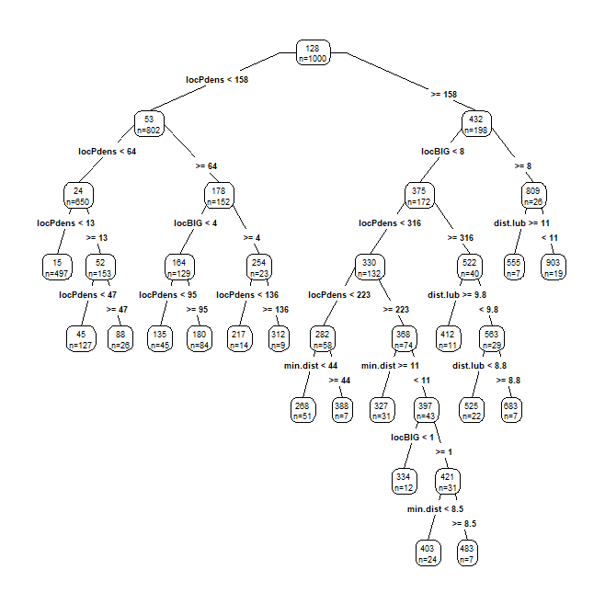

How to read the tree? Each box in the tree represents a subgroup of firms.
- The top number in the box is the predicted value of the dependent variable (locAggTOTAL) for that group.
- The bottom line (n=) shows how many observations belong to that node.
- The text above branches gives the splitting rule.
The tree starts from the root node, which contains all 1000 firms.

The first (and strongest) split is local population density (locPdens < 158) - this means that the algorithm found local population density to be the most important first separator of firms to areas with higher and lower local population density. This already shows that denser areas are associated with a much higher level of local firm agglomeration. On the left side of the tree, predicted values are mostly much lower. On the right side, predicted values rise strongly, often above 400, 500, or even 800. The root node has a predicted value of about 128 for the full sample. This is consistent with the Random Forest importance plot, where locPdens was also the leading predictor. So the main message is that firm agglomeration is substantially higher in densely populated environments.
The effect of density is non-linear - the tree uses locPdens repeatedly, with thresholds such as: 13, 47, 64, 95, 136, 158, 223, 316 what identifies several thresholds at which the expected agglomeration level changes sharply. The effect of density changes across ranges. This illustrayes thresholds, step changes and non-linearities.

There are interactions with other spatial variables. After splitting by locPdens, the tree uses additional variables such as: locBIG, dist.lub and min.dist. This means that the effect of one variable depends on the value of another. For example: in dense places, the number of big firms nearby (locBIG) further differentiates local agglomeration; in some branches, distance to Lublin (dist.lub) still matters; in others, minimum distance to important centres (min.dist) refines the prediction. So the tree reveals interaction effects such as: density matters first, but among dense places the outcome depends further on local business structure and accessibility.

One can also interpret particular branches.
Low-density branch: For firms with very low local population density (locPdens < 13), the predicted agglomeration is only about 15. This corresponds to peripheral and sparsely populated areas, where there are relatively few neighbouring firms. If density is still low but not minimal (locPdens between about 13 and 47), predicted agglomeration rises to around 45, and then to around 88 for somewhat denser places. So even within the low-density category, there is a clear gradient.
Medium-density branch: For firms in moderately dense areas (locPdens >= 64 on the left side), the tree next checks locBIG. Where there are more large firms nearby, the predicted agglomeration is much higher. This suggests that large firms may be an anchor of local economic concentration.
High-density branch: For firms in high-density areas (locPdens >= 158), predicted agglomeration jumps to about 432 already at the second node. Then locBIG becomes important again. If there are many big firms nearby (locBIG >= 8), predicted agglomeration becomes extremely high, reaching around 809, and even 903 in one terminal node.
This suggests that the strongest agglomeration occurs in places that combine: high population density, many big firms nearby and relatively favourable accessibility. These are likely the most urbanised and economically concentrated locations.

* * *

Trees can be obtained also with treeheatr:: - this package makes some extra colours for variables that are classified. This procedure takes very long

library(treeheatr)

sub<-firms.sel[,c("dummy_serv", "roa", "dummy_agri", "dummy_prod", "dummy_constr", "empl_av_size", "locPdens", "locAggTOTAL", "COREfirms", "locBIG", "dist.lublin", "min.dist")] # x variables

tree.rf<-compute_tree(sub, target_lab="locAggTOTAL")
draw_tree(tree.rf$dat, tree.rf$fit, tree.rf$term_dat, tree.rf$layout)
treeheatr(sub, target_lab="locAggTOTAL")
eval_tree(tree.rf$dat)
[1] "ACCURACY: 0.0780\nBAL_ACCURACY: 0.5111\nKAP: 0.0615\nROC_AUC: 0.4907\nPR_AUC: 0.0575"

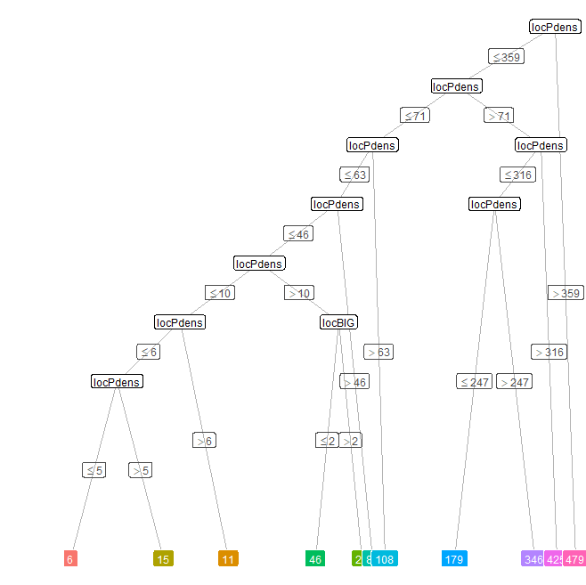

# optimization of models – hyperparameter tuning

The tuning process evaluates different combinations of two key parameters:
- nodesize – minimum number of observations in terminal tree nodes
- mtry – number of predictors randomly considered at each split

library(randomForestSRC)

my.tune<-tune(eq, data=firms.sel)
my.tune
$results
nodesize mtry err
1 1 1 0.29131206
2 1 2 0.08055295
3 1 3 0.04118303
4 1 4 0.03693306

215 85 5 0.35800456
216 85 6 0.33071131
217 85 7 0.34789397
218 85 8 0.31143812
219 85 9 0.31511207

$optimal
nodesize mtry
1 8

$rf
Sample size: 1000
Number of trees: 500
Forest terminal node size: 1
Average no. of terminal nodes: 171.512
No. of variables tried at each split: 8
Total no. of variables: 9
Resampling used to grow trees: swor
Resample size used to grow trees: 178
Analysis: RF-R
Family: regr
Splitting rule: mse *random*
Number of random split points: 1
(OOB) R squared: 0.95832347
(OOB) Requested performance error: 1423.79088879

The error value decreases strongly when mtry increases for small node sizes. This means that allowing more candidate variables at each split improves predictive performance. At the same time, large node sizes perform worse, which indicates that deeper trees are necessary to capture the complexity of the data. The tuning procedure selected: nodesize = 1 (trees are allowed to grow very deep, with terminal nodes containing a single observation) and mtry = 8 (almost all predictors (8 out of 9 variables) are considered at each split). This suggests that the relationship between predictors and firm agglomeration is complex and benefits from flexible tree structures.

Random Forest uses out-of-bag observations to estimate prediction error without needing a separate test dataset.
Results OOB R² = 0.958 means that the model explains approximately 95.8% of variance in the dependent variable (locAggTOTAL). This confirms the very strong predictive power of the spatial variables included in the model.
The requested performance error OOB MSE ≈ 1423.8 represents the average squared prediction error for out-of-bag observations.

In this step we optimise the terminal node size (nodesize) using the function tune.nodesize() from the randomForestSRC package. The procedure evaluates many possible values of nodesize, from very small nodes (1 observation) to large nodes (up to 150 observations), and calculates the prediction error for each.

my.nodesize<-tune.nodesize(eq, firms.sel, nodesizeTry=c(1:9, seq(10, 150, by=5)), ntreeTry=100, sampsize=function(x){min(x*.632, max(150, x^(4/5)))}, nsplit=1, trace=TRUE)

effective sampsize: 251 of 1000
nodesize = 1 reps = 1 error = 4.89%
nodesize = 2 reps = 1 error = 6.17%
nodesize = 3 reps = 1 error = 6.25%
nodesize = 4 reps = 1 error = 6.91%
nodesize = 5 reps = 1 error = 8.32%
nodesize = 6 reps = 1 error = 9.73%
nodesize = 7 reps = 1 error = 9.66%
nodesize = 8 reps = 1 error = 9.91%
nodesize = 9 reps = 1 error = 10.36%
nodesize = 10 reps = 1 error = 11.97%
nodesize = 15 reps = 1 error = 15.56%
nodesize = 20 reps = 1 error = 17.86%
nodesize = 25 reps = 1 error = 21.23%
nodesize = 30 reps = 1 error = 24.99%
nodesize = 35 reps = 1 error = 25.99%
nodesize = 40 reps = 1 error = 26.82%
nodesize = 45 reps = 1 error = 31.83%
nodesize = 50 reps = 1 error = 32.52%
nodesize = 55 reps = 1 error = 33.06%
nodesize = 60 reps = 1 error = 34.25%
nodesize = 65 reps = 1 error = 34.88%
nodesize = 70 reps = 1 error = 35.57%
nodesize = 75 reps = 1 error = 35.64%
nodesize = 80 reps = 1 error = 35.73%
nodesize = 85 reps = 1 error = 36.05%
nodesize = 90 reps = 1 error = 36.47%
nodesize = 95 reps = 1 error = 36.5%
nodesize = 100 reps = 1 error = 36.57%
nodesize = 105 reps = 1 error = 36.93%
nodesize = 110 reps = 1 error = 37%
nodesize = 115 reps = 1 error = 37.3%
nodesize = 120 reps = 1 error = 39.15%
nodesize = 125 reps = 1 error = 40.56%
optimal nodesize: 1

The tuning procedure reports: ‘effective sampsize: 251 of 1000’ what means that each tree was trained on about 251 observations sampled from the dataset of 1000 firms. This subsampling helps reduce correlation between trees and makes the tuning process computationally faster. There is clear pattern: prediction error increases steadily as node size increases. This means that small nodes give better predictive accuracy. This suggests that the relationship between spatial predictors and firm agglomeration is highly nonlinear and involves many threshold effects.

plot(my.nodesize$err, type="l")

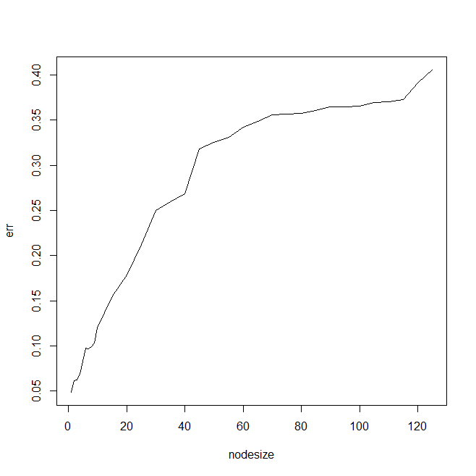

model.any<-rfsrc(eq, data=firms.sel, importance=TRUE) # any model
model.opti<-rfsrc(eq, data=firms.sel, importance=TRUE, nodesize=1, mtry=8)
model.any
model.opti
Any model | Fine-tuned model
Sample size: 1000  Number of trees: 500  Forest terminal node size: 5  Average no. of terminal nodes: 125.794  No. of variables tried at each split: 3  Total no. of variables: 9  Resampling used to grow trees: swor  Resample size used to grow trees: 632  Analysis: RF-R  Family: regr  Splitting rule: mse *random*  Number of random split points: 10  (OOB) R squared: 0.96564469  (OOB) Requested performance error: 1173.67663185 | Sample size: 1000  Number of trees: 500  Forest terminal node size: 1  Average no. of terminal nodes: 569.392  No. of variables tried at each split: 8  Total no. of variables: 9  Resampling used to grow trees: swor  Resample size used to grow trees: 632  Analysis: RF-R  Family: regr  Splitting rule: mse *random*  Number of random split points: 10  (OOB) R squared: 0.96662062  (OOB) Requested performance error: 1140.33612955

plot(vimp(model.any))
plot(vimp(model.opti))
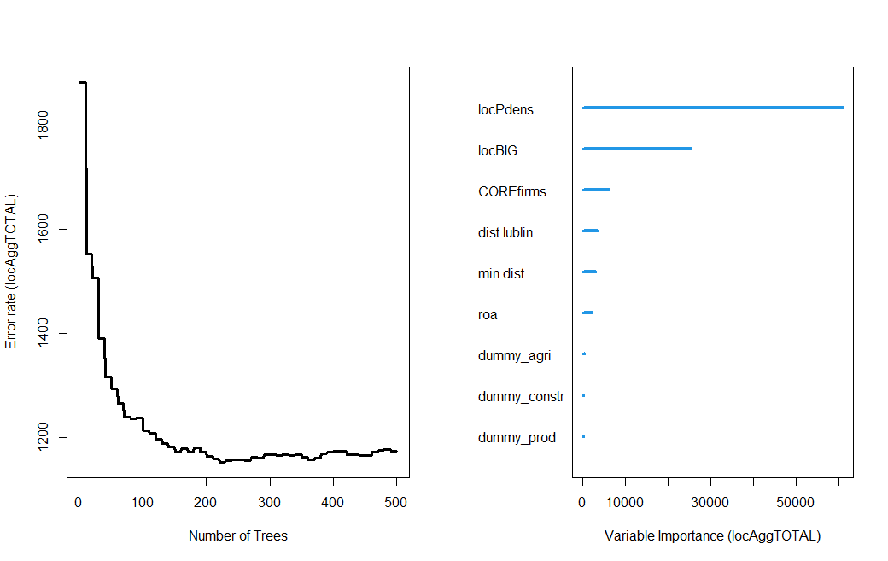 | 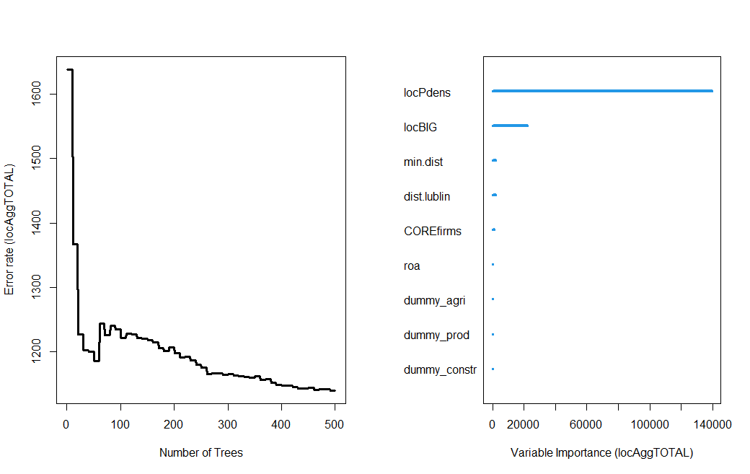

Any model | Fine-tuned model
Importance Relative Imp  locPdens 60973.3154 1.0000  locBIG 25494.5634 0.4181  COREfirms 6142.6141 0.1007  dist.lublin 3420.9329 0.0561  min.dist 2949.3200 0.0484  roa 2159.6250 0.0354  dummy_agri 353.7024 0.0058  dummy_constr 176.9616 0.0029  dummy_prod 150.7244 0.0025 | Importance Relative Imp  locPdens 139542.3523 1.0000  locBIG 22050.8347 0.1580  min.dist 1905.2359 0.0137  dist.lublin 1807.2418 0.0130  COREfirms 1004.3457 0.0072  roa 211.8766 0.0015  dummy_agri 76.2318 0.0005  dummy_prod 43.7040 0.0003  dummy_constr 4.7382 0.0000

plot.variable(model.opti, "dist.lublin")
plot.variable(model.opti, "locPdens")
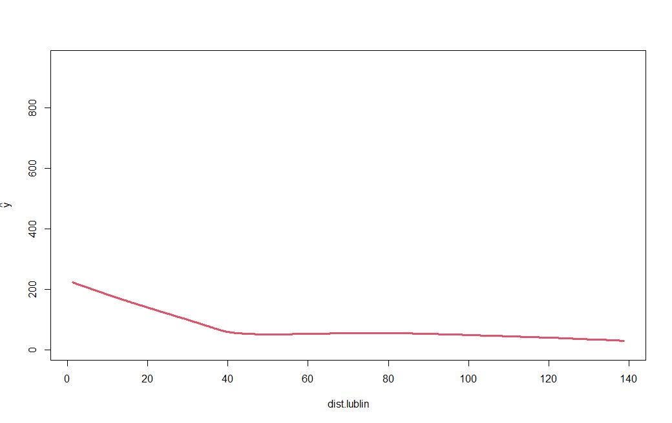 | 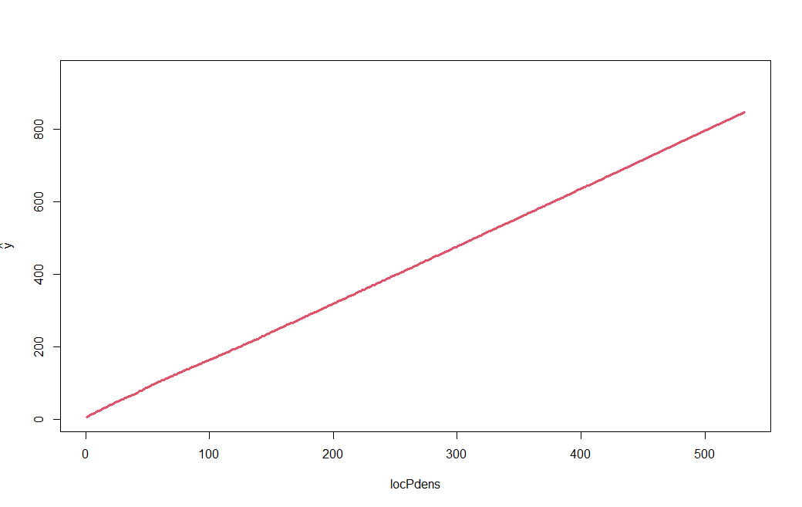

model.opti$predicted
[1] 17.208 43.388 24.534 6.254 10.044 279.846 856.380 476.310 9.702
[10] 178.834 182.902 383.852 7.476 29.968 380.058 7.162 14.376 68.500
[19] 422.270 6.832 7.016 252.864 642.392 169.524 5.338 402.306 18.110
[28] 369.978 14.984 170.988 51.654 17.166 17.012 11.788 10.610 43.190

firms.sel.sf$pred<-model.opti$predicted
plot(firms.sel.sf["pred"])

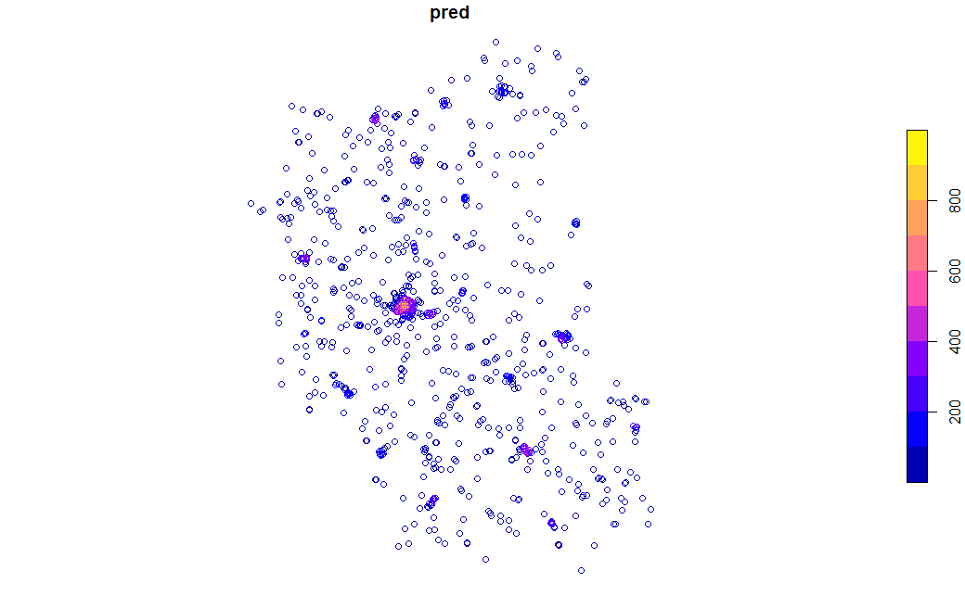

# Spatial Lag Model Tree

In addition to Random Forest, spatial machine learning can also combine tree partitioning with spatial econometric models. One such method is implemented in the lagsarlmtree:: package. The idea is to divide the dataset into groups using a tree structure, and then estimate a spatial lag model within each node. This allows relationships to vary across different spatial environments while still controlling for spatial dependence.
The model uses a spatial weights matrix created with tessW() function from spatialWarsaw:: package. This creates a tessellation-based neighbourhood structure, defining which firms are considered spatial neighbours. The spatial weights matrix allows the model to account for spatial spillovers, meaning that the outcome in one location may depend on outcomes in nearby locations.

eq<-locAggTOTAL ~ dummy_agri + dummy_prod + dummy_constr + locPdens + COREfirms + locBIG + dist.lublin + min.dist + roa

packageinstall.packages("devtools") # to install from Github
devtools::install_github("poktam/spatialWarsaw")
library(spatialWarsaw)

my.tess<-tessW(firms.sel.sf, region.voi, sample_size=nrow(firms.sel.sf))
my.tess # spatial weights matrix based on Voronoi tesselation

library(lagsarlmtree) # spatial lag model tree
tree.model<-lagsarlmtree(eq, data=firms.sel, listw=my.tess, minsize=12, alpha=0.05)
tree.model # display the result
plot(tree.model) # plot the result

Spatial lag model tree

Model formula:
locAggTOTAL ~ 1 | dummy_agri + dummy_prod + dummy_constr + locPdens +
COREfirms + locBIG + dist.lublin + min.dist + roa

Fitted party:
[1] root
| [2] locPdens <= 157
| | [3] locPdens <= 58
| | | [4] locPdens <= 12
| | | | [5] locPdens <= 6
| | | | | [6] locPdens <= 3: n = 66
| | | | | (Intercept)
| | | | | 4.942292
| | | | | [7] locPdens > 3
| | | | | | [8] min.dist <= 37.86222: n = 188
| | | | | | (Intercept)
| | | | | | 8.090111
| | | | | | [9] min.dist > 37.86222: n = 115
| | | | | | (Intercept)
| | | | | | 12.90604
| | | | [10] locPdens > 6: n = 196
| | | | (Intercept)
| | | | 22.33803
| | | [11] locPdens > 12
| | | | [12] locPdens <= 32
| | | | | [13] min.dist <= 21.81227: n = 44
| | | | | (Intercept)
| | | | | 32.95608
| | | | | [14] min.dist > 21.81227: n = 66
| | | | | (Intercept)
| | | | | 49.88901
| | | | [15] locPdens > 32: n = 42
| | | | (Intercept)
| | | | 85.30469
| | [16] locPdens > 58
| | | [17] locPdens <= 103
| | | | [18] locBIG <= 2
| | | | | [19] locPdens <= 77: n = 14
| | | | | (Intercept)
| | | | | 109.2005
| | | | | [20] locPdens > 77: n = 21
| | | | | (Intercept)
| | | | | 138.9481
| | | | [21] locBIG > 2: n = 17
| | | | (Intercept)
| | | | 174.4917
| | | [22] locPdens > 103
| | | | [23] locBIG <= 3
| | | | | [24] COREfirms <= 0: n = 17
| | | | | (Intercept)
| | | | | 218.1108
| | | | | [25] COREfirms > 0: n = 26
| | | | | (Intercept)
| | | | | 178.6936
| | | | [26] locBIG > 3: n = 17
| | | | (Intercept)
| | | | 256.7691
| [27] locPdens > 157
| | [28] locBIG <= 7
| | | [29] locPdens <= 232
| | | | [30] locBIG <= 3
| | | | | [31] locPdens <= 195: n = 26
| | | | | (Intercept)
| | | | | 225.0972
| | | | | [32] locPdens > 195: n = 23
| | | | | (Intercept)
| | | | | 282.3693
| | | | [33] locBIG > 3: n = 15
| | | | (Intercept)
| | | | 333.9763
| | | [34] locPdens > 232
| | | | [35] dist.lublin <= 10.70166
| | | | | [36] locBIG <= 3
| | | | | | [37] locPdens <= 373: n = 14
| | | | | | (Intercept)
| | | | | | 415.3337
| | | | | | [38] locPdens > 373: n = 13
| | | | | | (Intercept)
| | | | | | 524.2854
| | | | | [39] locBIG > 3: n = 16
| | | | | (Intercept)
| | | | | 570.0355
| | | | [40] dist.lublin > 10.70166: n = 38
| | | | (Intercept)
| | | | 375.5218
| | [41] locBIG > 7
| | | [42] dist.lublin <= 10.37532: n = 14
| | | (Intercept)
| | | 864.0908
| | | [43] dist.lublin > 10.37532: n = 12
| | | (Intercept)
| | | 639.4152

Number of inner nodes: 21
Number of terminal nodes: 22
Number of parameters per node: 1
Objective function (residual sum of squares): 1432359

Rho (from lagsarlm model):
rho
0.007131089

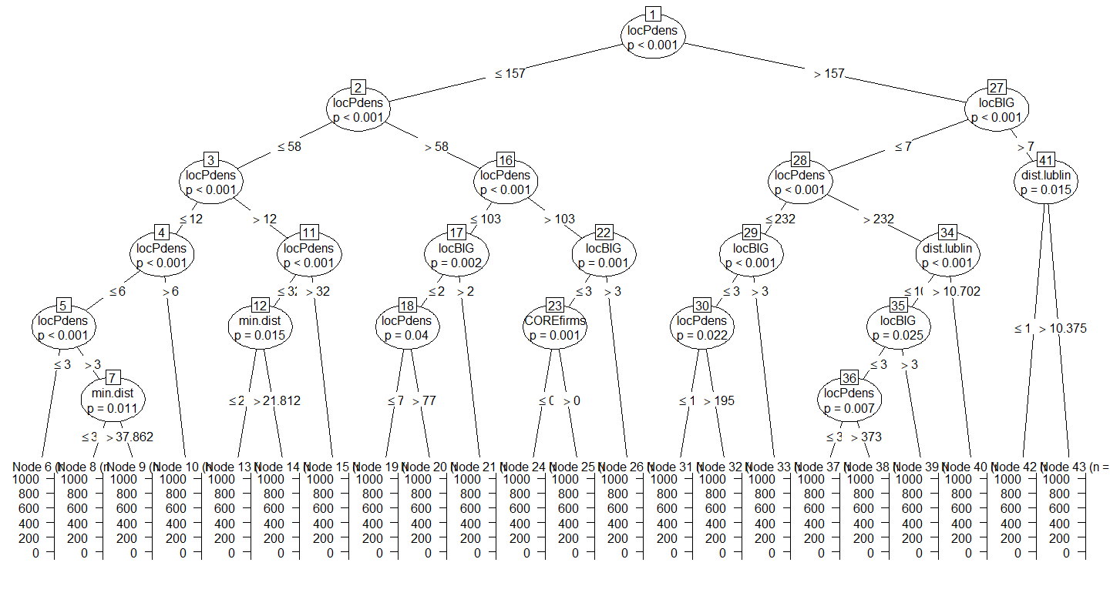

The estimated model contains 21 internal nodes and 22 terminal nodes. Each terminal node corresponds to a subgroup of firms with similar characteristics. Within each node the model estimates a simple spatial lag model, which in this example includes only an intercept (constant mean prediction within that group). The first split in the tree is locPdens <= 157 - this confirms earlier results from the Random Forest analysis: local population density is the most important factor shaping firm agglomeration.
The model also estimates the spatial autoregressive coefficient: rho = 0.007. This parameter measures spatial dependence in the dependent variable. The value is very small, indicating only weak spatial spillover effects after accounting for the explanatory variables and tree partitioning. Most spatial structure appears to be captured by the explanatory variables themselves (population density, proximity to cities, etc.). This is an important result: the tree partitions may already absorb most of the spatial heterogeneity.

* * *
Alternative estimation uses eigenvalue method with eigenw() function. This version uses eigenvalue decomposition of the spatial weights matrix to estimate the spatial lag model more efficiently. Precomputing eigenvalues (pre_eig=ev) speeds up estimation, especially when the spatial weights matrix is large. Substantively, the resulting tree structure is usually very similar, because the partitioning procedure is driven mainly by the explanatory variables rather than the estimation algorithm.

ev<-eigenw(my.tess) # from spdep::
tree.model2<-lagsarlmtree(eq, data=firms.sel, listw=my.tess, method="eigen", control=list(pre_eig=ev), minsize=12, alpha=0.05)
tree.model2 # display the new model
plot(tree.model2) # plot the tree model


# Spatial Random Forest

The spatialRF:: package extends Random Forest by adding spatial information directly into the modelling process. Here, two approaches are compared:
- mem.moran.sequential – adds spatial predictors only when needed to remove residual spatial autocorrelation,
- hengl – uses the distance matrix itself as a large set of spatial predictors.

This example presents four models:
- model with spatial variables, method Moran
- model with spatial variables, method Hengl
- model without explicit spatial variables, method Moran
- model without explicit spatial variables, method Hengl
This is a very useful setup because it separates the role of:
- substantive spatial covariates such as dist.lublin, min.dist, COREfirms,
- pure coordinate-based spatial structure captured by distance-based spatial predictors.

library(spatialRF)

# eq<-locAggTOTAL ~ dummy_agri + dummy_prod + dummy_constr + locPdens + COREfirms + locBIG + dist.lublin + min.dist + roa

my.data<-firms.sel
my.dep.var<-"locAggTOTAL"
my.pred.var<-c("dummy_agri", "dummy_prod", "dummy_constr", "locPdens", "COREfirms", "locBIG", "dist.lublin", "min.dist", "roa")
my.dist.mat<-as.matrix(dist(firms.sel[,c("new.x", "new.y")]))
my.dist.thres<-c(0.05, 0.1, 0.5) # 1 is ca. 100 km

#fit spatial model - method mem.moran.sequential
m_spatial_1<-rf_spatial(data=my.data, dependent.variable.name=my.dep.var, predictor.variable.names=my.pred.var, distance.matrix=my.dist.mat, distance.thresholds=my.dist.thres, method="mem.moran.sequential", ranger.arguments=list(num.trees=30), n.cores=1)

Model type
- Fitted with: ranger()
- Response variable: locAggTOTAL

Random forest parameters
- Type: Regression
- Number of trees: 30
- Sample size: 1000
- Number of predictors: 9
- Mtry: 3
- Minimum node size: 5

Model performance
- R squared (oob): 0.954815
- R squared (cor(obs, pred)^2): 0.9913392
- Pseudo R squared (cor(obs, pred)):0.9956602
- RMSE (oob): 37.28122
- RMSE: 17.053
- Normalized RMSE: 0.123349

Model residuals
- Stats:
┌────────┬────────┬────────┬──────┬────────┬────────┐
│ Min. │ 1st Q. │ Median │ Mean │ 3rd Q. │ Max. │
├────────┼────────┼────────┼──────┼────────┼────────┤
│ -70.64 │ -6.40 │ -2.12 │ 0.23 │ 4.55 │ 147.45 │
└────────┴────────┴────────┴──────┴────────┴────────┘
- Normality:
- Shapiro-Wilks W: 0.822
- p-value : 0
- Interpretation : Residuals are not normal

- Spatial autocorrelation:
┌──────────┬───────────┬─────────┬────────────────────┐
│ Distance │ Moran's I │ P value │ Interpretation │
├──────────┼───────────┼─────────┼────────────────────┤
│ 0.0 │ -0.001 │ 0.853 │ No spatial │
│ │ │ │ correlation │
├──────────┼───────────┼─────────┼────────────────────┤
│ 0.1 │ 0.001 │ 0.101 │ No spatial │
│ │ │ │ correlation │
├──────────┼───────────┼─────────┼────────────────────┤
│ 0.5 │ -0.001 │ 0.710 │ No spatial │
│ │ │ │ correlation │
└──────────┴───────────┴─────────┴────────────────────┘

Variable importance:
┌──────────────┬────────────┐
│ Variable │ Importance │
├──────────────┼────────────┤
│ locPdens │ 166.036 │
├──────────────┼────────────┤
│ locBIG │ 71.817 │
├──────────────┼────────────┤
│ dist.lublin │ 64.119 │
├──────────────┼────────────┤
│ COREfirms │ 55.216 │
├──────────────┼────────────┤
│ min.dist │ 48.252 │
├──────────────┼────────────┤
│ roa │ 19.120 │
├──────────────┼────────────┤
│ dummy_agri │ 15.606 │
├──────────────┼────────────┤
│ dummy_prod │ -3.532 │
├──────────────┼────────────┤
│ dummy_constr │ -9.339 │
└──────────────┴────────────┘

plot_residuals_diagnostics(m_spatial_1)
plot_importance(m_spatial_1)
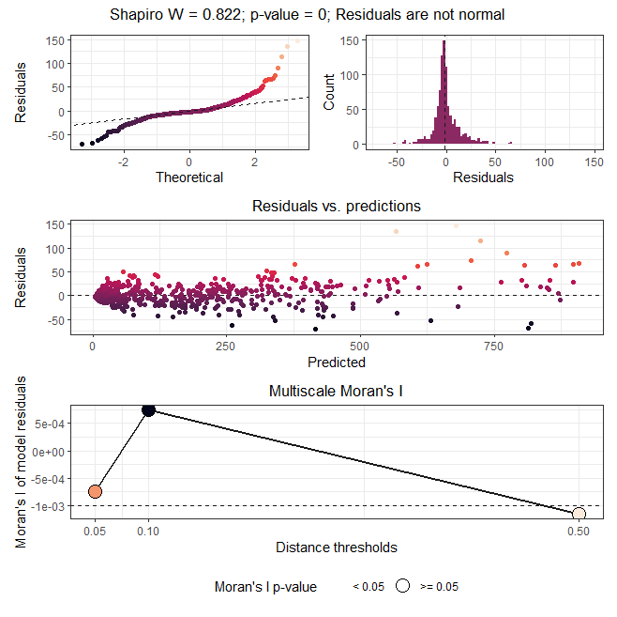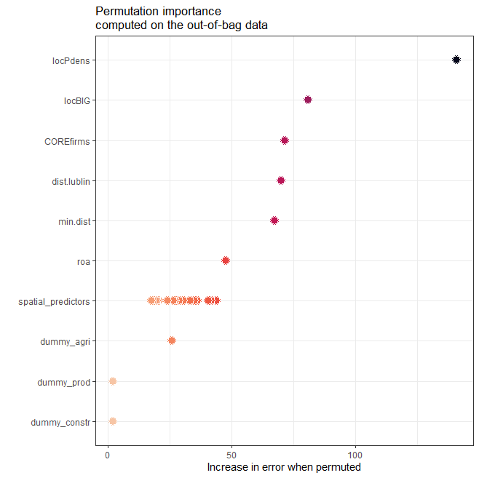

plot_optimization(m_spatial_1) #optimization of MEM selection
No optimization data available. This happens when:
- No spatial predictors were selected
- The method used was 'hengl' (no optimization required)
- The model is non-spatial

plot_response_surface(m_spatial_1, grid.resolution=50)
plot_response_surface(m_spatial_1, a="dist.lublin", b="roa", grid.resolution=50)

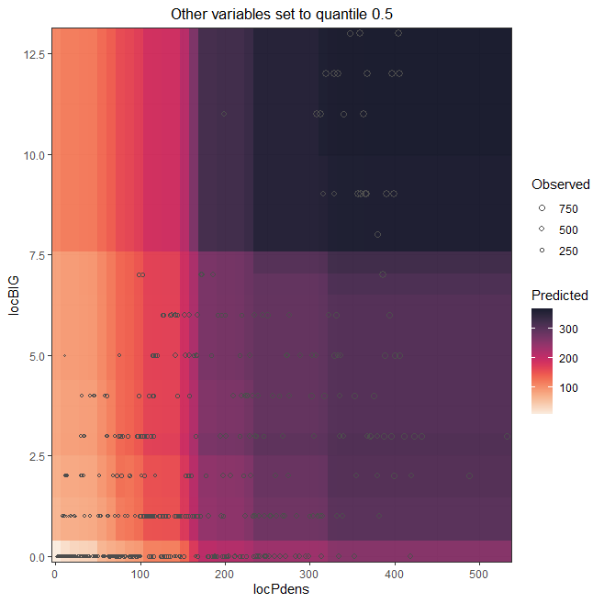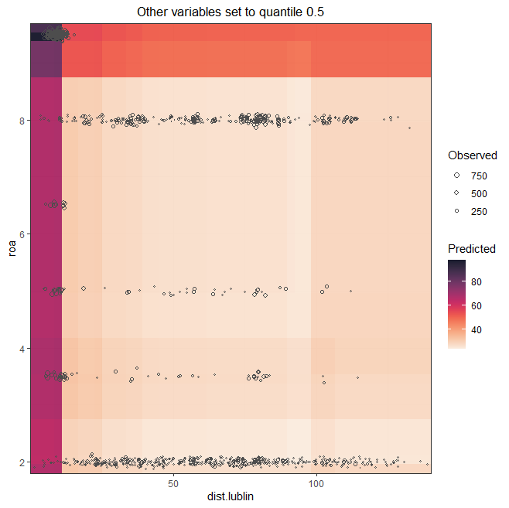

# fit spatial model – method hengl
m_spatial_2<-rf_spatial(data=my.data, dependent.variable.name=my.dep.var, predictor.variable.names=my.pred.var, distance.matrix=my.dist.mat, distance.thresholds=my.dist.thres, method="hengl", ranger.arguments= list(num.trees=30), n.cores=1)

# models with no spatial variables
# eq<-locAggTOTAL ~ dummy_agri + dummy_prod + dummy_constr + locPdens + locBIG + roa

my.data<-firms.sel
my.dep.var<-"locAggTOTAL"
my.pred.var<-c("dummy_agri", "dummy_prod", "dummy_constr", "locPdens", "locBIG", "roa")
my.dist.mat<-as.matrix(dist(firms.sel[,c("new.x", "new.y")]))
my.dist.thres<-c(0.05, 0.1, 0.5) # 1 is ca. 100 km

#fit spatial model – method mem.moran.sequential
m_spatial_3<-rf_spatial(data=my.data, dependent.variable.name=my.dep.var, predictor.variable.names=my.pred.var, distance.matrix=my.dist.mat, distance.thresholds=my.dist.thres, method="mem.moran.sequential", ranger.arguments=list(num.trees=30), n.cores=1)

#fit spatial model – method hengl
m_spatial_4<-rf_spatial(data=my.data, dependent.variable.name=my.dep.var, predictor.variable.names=my.pred.var, distance.matrix=my.dist.mat, distance.thresholds=my.dist.thres, method="hengl", ranger.arguments=list(num.trees=30), n.cores=1)

Model with spatial variables | Model with spatial variables | Model without spatial variables | Model without spatial variables
Method Moran | Method Hengl | Method Moran | Method Hengl
Model performance  - R squared (oob): 0.954815  - R squared (cor(obs, pred)^2): 0.9913392  - Pseudo R squared (cor(obs, pred)):0.9956602  - RMSE (oob): 37.28122  - RMSE: 17.053  - Normalized RMSE: 0.123349 | Model performance  - R squared (oob): 0.9625908  - R squared (cor(obs, pred)^2): 0.9938881  - Pseudo R squared (cor(obs, pred)):0.9969394  - RMSE (oob): 33.92207  - RMSE: 14.138  - Normalized RMSE: 0.102264 | Model performance  - R squared (oob): 0.9082049  - R squared (cor(obs, pred)^2): 0.9642657  - Pseudo R squared (cor(obs, pred)):0.9819703  - RMSE (oob): 53.13772  - RMSE: 35.3743  - Normalized RMSE: 0.255872 | Model performance  - R squared (oob): 0.9572048  - R squared (cor(obs, pred)^2): 0.9929555  - Pseudo R squared (cor(obs, pred)):0.9964715  - RMSE (oob): 36.28197  - RMSE: 15.1458  - Normalized RMSE: 0.1095537
 | The best model

Estimation strategy assumed four models: with / without spatial variables and using Moran or Hengl procedure. Models assume inclusion of extra spatial eigenvector-type predictors are needed to remove residual spatial autocorrelation (Moran) or adding many distance-based spatial predictors derived from the coordinates (Hengl). Procedure reports performance, where fit (OOB R²) should be high and error should be low (RMSE (OOB), RMSE and normalized RMSE). Test of normality of residuals (Shapiro-Wilk test) are not that much important as in classical linear regression, because tree-based methods do not require normally distributed residuals. In testing residuals, spatial autocorrelation tested with Moran’s I is more essential – good model should not evidence this issue.

For comparisons of models one get the following messages:
- due to inclusion of spatial predictors already in the model, the residuals no longer show spatial structure - so the model appears to have captured the relevant spatial pattern successfully. The original set of explanatory variables already removed spatial autocorrelation, so the algorithm did not need to add extra MEM spatial predictors. That is actually a success, not a failure.
- Variable importance is as before: locPdens — by far the strongest predictor. The sector dummies contribute very little, and some even have negative importance (dummy_prod, dummy_constr). In RF, negative permutation importance usually means the variable contributes little useful information and may add noise.
- Models estimated using Hengl procedure perform better than those with Moran - it means distance-based spatial predictors can reconstruct a large part of the missing spatial signal.
- Inclusion of spatial variables improves the predictive performance of models - this is strong evidence that variables such as dist.lublin, min.dist, and COREfirms contain essential information.

Interpretation of the residual diagnostics figure
Normal Q-Q plot and histogram: These show that residuals are not normally distributed, with a long positive tail and some large positive residuals. This means that the model tends to predict well for most firms, but a small number of observations have unusually large residuals, what this may indicate outliers or rare local contexts. For Random Forest this is not a major violation, because normal residuals are not required.
Residuals vs predictions: The residuals appear centred around zero, but the spread changes somewhat across the prediction range, with a few extreme observations at high fitted values. This means that the model is broadly well calibrated, but error variance may be slightly larger for some parts of the outcome range.
Multiscale Moran’s I panel: It shows Moran’s I across several distance thresholds, with p-values above 0.05. This means that residuals are spatially random across the tested scales. That means the model has done what a spatial model should do: it has absorbed the spatial structure, so the unexplained component is no longer spatially patterned.

# Generate spatial predictors using multiple distance thresholds
mem.df<-mem(distance.matrix=my.dist.mat)
spatial.predictors.filtered<-filter_spatial_predictors(data=my.data, predictor.variable.names=my.pred.var, spatial.predictors.df=mem.df, cor.threshold=0.50)
spatial.predictors.filtered[1:10, 1:10]
mem_1 mem_2 mem_3 mem_4 mem_5
1 0.001619164 0.0010388725 0.0020170396 0.0030607160 -0.024412734
2 0.000851770 0.0011825019 -0.0008909032 0.0003996767 0.002550417
3 0.001022019 -0.0002844648 0.0003434280 0.0034184932 -0.007403710
4 0.001233731 0.0001110592 0.0006972214 0.0012570895 -0.003174253
5 0.001368494 0.0011043954 0.0014554283 -0.0033276422 0.002895773
6 0.003185227 0.0012233230 0.0038279833 0.0098518907 -0.057508216
7 0.003622377 0.0054916560 0.0092236277 -0.0438476254 0.056615601
8 0.003948184 0.0028621866 0.0062600549 0.0109380488 -0.091057946
9 0.002476489 -0.0016641453 0.0003812312 0.0132188058 -0.021267498
10 0.000908976 0.0022297616 0.0022422947 -0.0024168259 -0.010774808
mem_6 mem_7 mem_8 mem_9 mem_10
1 0.0050082244 -0.0197222575 0.029251267 6.777337e-03 0.0111559023
2 -0.0010922559 -0.0012625063 -0.011401024 1.012316e-02 -0.0092513923
3 0.0001860424 0.0008801931 -0.009555929 -2.483953e-03 0.0079128786
4 -0.0012668119 -0.0008067007 -0.005133807 -1.327162e-03 0.0015697266
5 -0.0008300888 0.0004376541 -0.002331818 -8.979984e-05 -0.0001793351
6 0.0115501651 -0.0263245244 -0.009894720 -1.788444e-01 -0.0494385969
7 0.0024864367 0.0243171070 0.027296134 -1.471725e-02 0.0137903136
8 0.0212341893 -0.0874754138 0.186902922 6.986351e-02 0.0901527250
9 -0.0036468764 -0.0004134747 -0.101840015 -1.193174e-02 0.1410133823
10 0.0025495141 -0.0155515795 -0.029138419 4.459382e-02 -0.0476392240

#rank spatial predictors from higher to lower moran
mems.rank<-rank_spatial_predictors(ranking.method = "moran", spatial.predictors.df= mem.df, reference.moran.i= m_spatial_1$residuals$autocorrelation$max.moran, distance.matrix= my.dist.mat, distance.thresholds=0.100, n.cores=1)
str(mems.rank)
List of 4
$ method : chr "moran"
$ criteria :'data.frame': 65 obs. of 3 variables:
..$ spatial.predictors.name: chr [1:65] "mem_5" "mem_11" "mem_10" "mem_8" ...
..$ ranking.criteria : num [1:65] 0.1096 0.0489 0.0429 0.0385 0.0355 ...
..$ interpretation : chr [1:65] "Positive spatial correlation" "Positive spatial correlation" "Positive spatial correlation" "Positive spatial correlation" ...
$ ranking : chr [1:65] "mem_5" "mem_11" "mem_10" "mem_8" ...
$ spatial.predictors.df:'data.frame': 1000 obs. of 65 variables:
..$ mem_5 : num [1:1000] -0.02441 0.00255 -0.0074 -0.00317 0.0029 ...
..$ mem_11 : num [1:1000] 4.17e-03 1.05e-02 6.82e-06 -2.23e-04 -6.35e-04 ...
..$ mem_10 : num [1:1000] 0.011156 -0.009251 0.007913 0.00157 -0.000179 ...
..$ mem_8 : num [1:1000] 0.02925 -0.0114 -0.00956 -0.00513 -0.00233 ...

#select best subset via sequential addition – takes very long!!!
selection<-select_spatial_predictors_recursive(data=my.data, dependent.variable.name=my.dep.var, predictor.variable.names=my.pred.var, distance.matrix=my.dist.mat, distance.thresholds=0, spatial.predictors.df=mem.df, spatial.predictors.ranking=mems.rank, ranger.arguments= list(num.trees=30), n.cores=1)

# feature enginieering

my.xy<-firms.sel[,c("new.x", "new.y")]
colnames(my.xy)<-c("x", "y")

feat.sel<-the_feature_engineer(data=my.data, dependent.variable.name=my.dep.var, predictor.variable.names=my.pred.var, xy=my.xy, repetitions = 30, training.fraction=0.75, importance.threshold=0.75, cor.threshold=0.75, point.color = viridis::viridis(100, option="F", alpha=0.8), seed=NULL, verbose=TRUE, n.cores=parallel::detectCores()-4, cluster=NULL)

Training and evaluating a model without interactions.
Testing 3 candidate interactions.
Komunikat ostrzegawczy:
W poleceniu 'the_feature_engineer(data = my.data, dependent.variable.name = my.dep.var, ':
No promising interactions found, returned NULL.

#*** Random Forest in classification (for binary y)

For binary dependent variable, procedures are similar, but outputs slightly differ

# second model – to explain if firm is in service sector – dummy y
eq<-dummy_serv ~ roa + dummy_agri + dummy_prod + dummy_constr + empl_av_size + locPdens + locAggTOTAL + COREfirms + locBIG + dist.lublin + min.dist

# randomForest::
sub<-firms.sel[,c("roa", "dummy_agri", "dummy_prod", "dummy_constr", "empl_av_size", "locPdens", "locAggTOTAL", "COREfirms", "locBIG", "dist.lublin", "min.dist")] # x variables
y<-as.factor(firms.sel[,"dummy_serv"]) # y variable

rf.global<-randomForest(sub, y, importance=TRUE)
rf.global
Call:
randomForest(x = sub, y = y, importance = TRUE)
Type of random forest: classification
Number of trees: 500
No. of variables tried at each split: 3

OOB estimate of error rate: 0%
Confusion matrix:
0 1 class.error
0 629 0 0
1 0 371 0

# visualization of random tree
cart<-rpart(eq, data=firms.sel, cp=0.001)
prp(cart, type=4, extra=1)
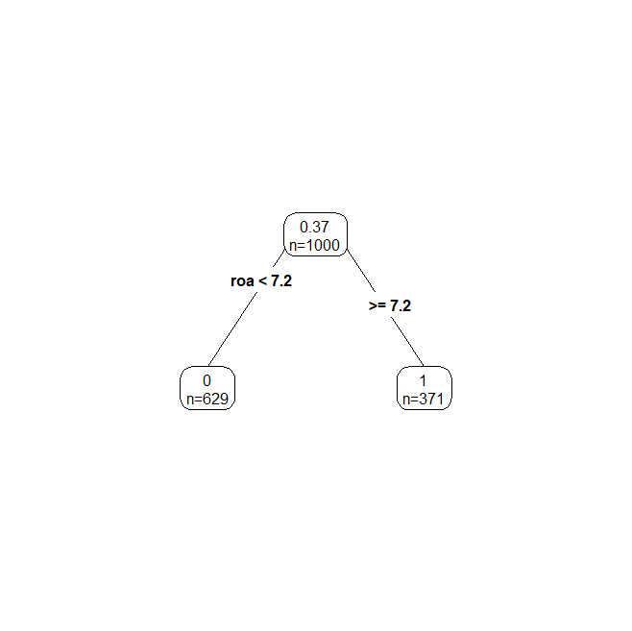

# OOB estimate # out-of-bag estimate (prediction on data not used in training)

varImpPlot(rf.global) # variable importance
partialPlot(rf.global, sub, dist.lublin, xlim=c(0,120)) # partial plots

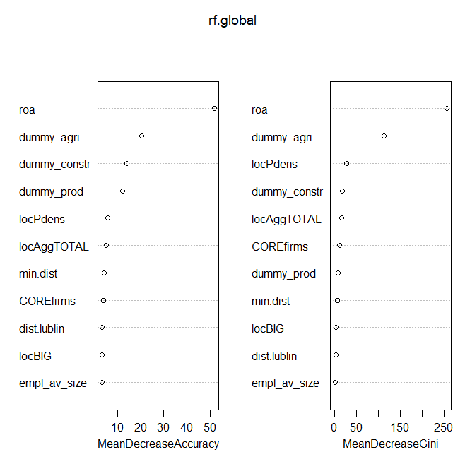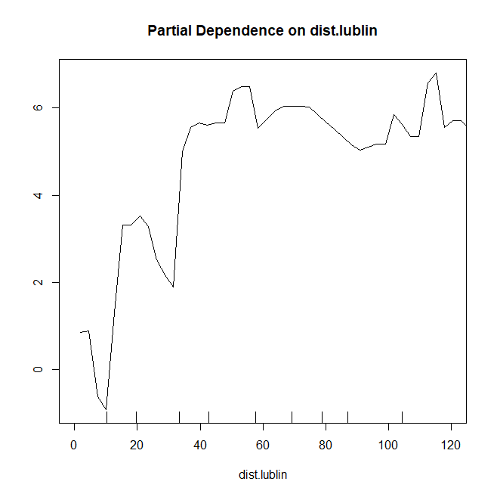
library(treeheatr)

sub<-firms.sel[,c("dummy_serv", "roa", "dummy_agri", "dummy_prod", "dummy_constr", "empl_av_size", "locPdens", "locAggTOTAL", "COREfirms", "locBIG", "dist.lublin", "min.dist")] # x variables

# for discrete specification (y is dummy)
tree.rf<-compute_tree(sub, target_lab="dummy_serv")
draw_tree(tree.rf$dat, tree.rf$fit, tree.rf$term_dat, tree.rf$layout)
treeheatr(sub, target_lab="dummy_serv")
eval_tree(tree.rf$dat)
[1] "ACCURACY: 1.000\nBAL_ACCURACY: 1.000\nKAP: 1.000\nROC_AUC: 0.492\nPR_AUC: 0.742"

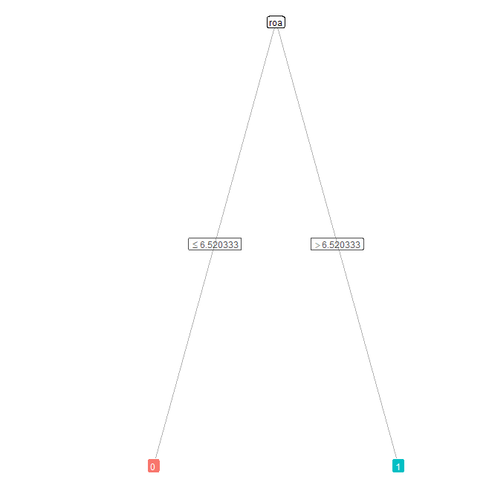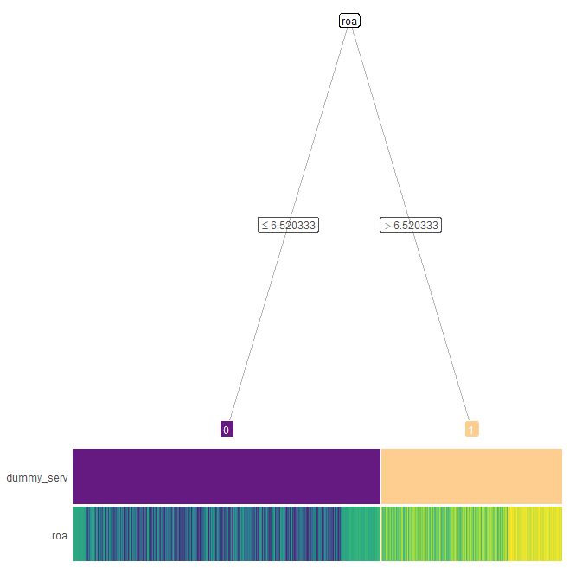

library(randomForestSRC)

my.tune<-tune(eq, data=firms.df.sel)
my.tune
$results
nodesize mtry err
1 1 2 3.445008e-02
2 1 3 1.365789e-02
3 1 4 6.744729e-03
4 1 5 1.850503e-03
5 1 6 1.499109e-03
$optimal
nodesize mtry
3 11

model.any<-rfsrc(eq, data=firms.df.sel, importance=TRUE) # any model
model.opti<-rfsrc(eq, data=firms.df.sel, importance=TRUE, nodesize=3, mtry=11)
model.any
model.opti

Any model | Fine-tuned model
Sample size: 1000  Number of trees: 500  Forest terminal node size: 5  Average no. of terminal nodes: 9.726  No. of variables tried at each split: 4  Total no. of variables: 11  Resampling used to grow trees: swor  Resample size used to grow trees: 632  Analysis: RF-R  Family: regr  Splitting rule: mse *random*  Number of random split points: 10  (OOB) R squared: 0.99738513  (OOB) Requested performance error: 0.00058224 | Sample size: 1000  Number of trees: 500  Forest terminal node size: 3  Average no. of terminal nodes: 4.232  No. of variables tried at each split: 11  Total no. of variables: 11  Resampling used to grow trees: swor  Resample size used to grow trees: 632  Analysis: RF-R  Family: regr  Splitting rule: mse *random*  Number of random split points: 10  (OOB) R squared: 0.99916211  (OOB) Requested performance error: 0.00018657

# swor is sampling without replacement

plot(vimp(model.any))
plot(vimp(model.opti))

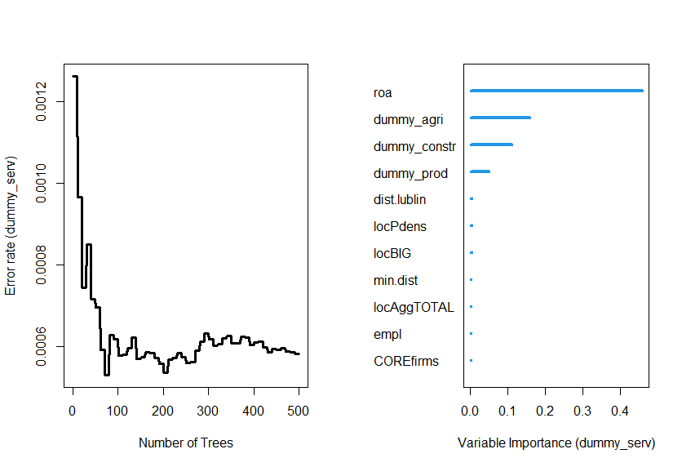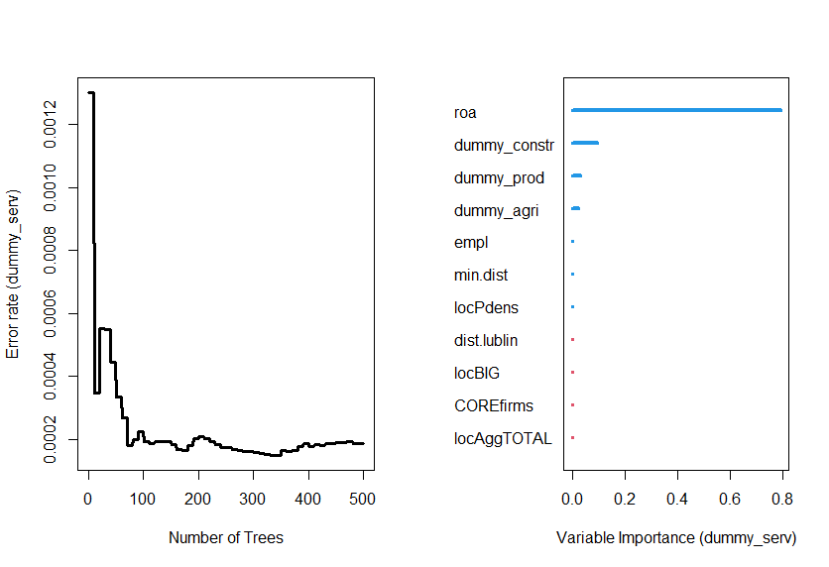

Any model | Fine-tuned model
Importance Relative Imp  roa 0.4586 1.0000  dummy_agri 0.1590 0.3467  dummy_constr 0.1107 0.2414  dummy_prod 0.0497 0.1084  dist.lublin 0.0031 0.0068  locPdens 0.0031 0.0067  locBIG 0.0028 0.0062  min.dist 0.0021 0.0045  locAggTOTAL 0.0015 0.0033  empl 0.0014 0.0031  COREfirms 0.0011 0.0024 | Importance Relative Imp  roa 0.7935 1.0000  dummy_constr 0.0963 0.1213  dummy_prod 0.0293 0.0369  dummy_agri 0.0247 0.0311  empl 0.0000 0.0000  min.dist 0.0000 0.0000  locPdens 0.0000 0.0000  dist.lublin 0.0000 0.0000  locBIG 0.0000 0.0000  COREfirms 0.0000 0.0000  locAggTOTAL 0.0000 0.0000

plot.variable(model.opti, "dist.lublin")
plot.variable(model.opti, "locPdens")
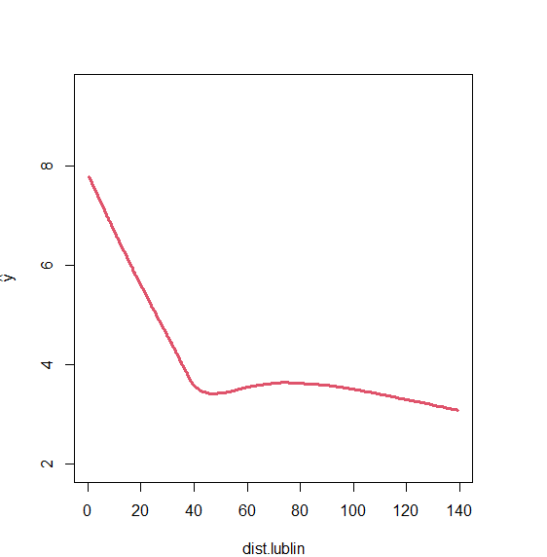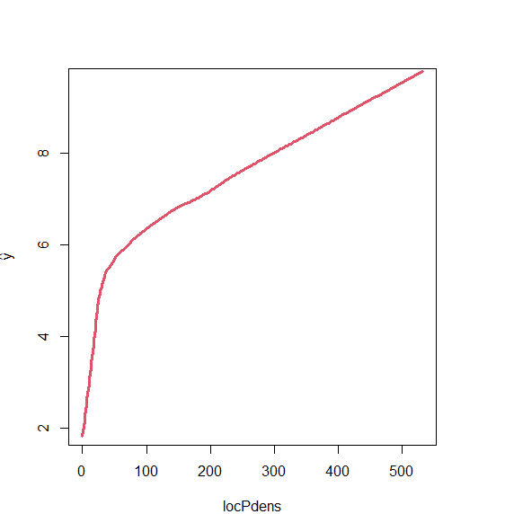
model.opti$predicted

[1] 0.0000000000 0.0000000000 1.0000000000 1.0000000000 1.0000000000 1.0000000000
[7] 0.0000000000 0.0000000000 0.0000000000 0.0000000000 0.0000000000 1.0000000000
[13] 0.0000000000 1.0000000000 0.0000000000 0.0000000000 0.0000000000 0.0000000000
[19] 0.0000000000 0.0000000000 1.0000000000 1.0000000000 0.0000000000 0.0000000000
[25] 0.0000000000 0.0000000000 1.0000000000 1.0000000000 0.0000000000 0.0000000000

https://cran.r-project.org/web/packages/randomForestExplainer/vignettes/randomForestExplainer.html

